Sampling-Bout Definition and Selectivity
Deliverable A -- Selective Sampling-Bout analysis (reactions_2). Required characterization (not a hypothesis test).

Purpose
This deliverable redefines the head-sampling event used in the reactions v1 analysis. The v1 detector flagged head-vs-body motion whenever a speed ratio exceeded R>=1.5 and swept that threshold. That approach was wrong for three reasons, and each motivates a specific design change here:
- Too frequent: the R>=1.5 sweep fired at roughly 1.7 events/s -- routine, near-continuous head motion rather than deliberate, rare sampling. The redesign targets a rare event and achieves a pooled median rate of 0.0073/s (232x rarer).
- Denominator-biased / circular: the R>=1.5 ratio has body speed (v_com) in the denominator, so an event was defined partly by the COM slowing -- then 'COM slows near a bout' was reported as a finding. That is circular. Here the trigger kinematic is translation-invariant (angular speed of the head-body bearing) and the low-COM condition is stated as DEFINITIONAL, never as a result.
- No odor coherence: v1 imposed no requirement that events relate to the odor landscape, and its sheer frequency guaranteed spurious odor overlap. The redesign first establishes a rare, selective event class (this deliverable), so that subsequent odor hypotheses (H1-H3) are tested on deliberate sampling rather than on background motion.

Methods
Data come through the project accessor only, using the shared library reactions2_common (which reuses plume_common and reactions_common; no science re-implemented). Analyses were run under the pinned interpreter (vras) with random seed 1234. Library version reactions2_common/1.0.
Kinematic (translation-invariant). The sampling trigger is the angular speed of the head-body bearing, omega = |d/dt bearing(head - body)| in deg/s. Because it uses only the head-relative-to-body orientation, omega is invariant to whole-animal translation and contains no v_com denominator -- removing the circularity of the v1 ratio.
Bout definition. A sampling bout is the conjunction of (i) a locomotor pause -- a contiguous run with v_com < v_pause = 5.89 px/s (25th percentile of pooled v_com) lasting at least tau_pause = 0.30 s -- containing (ii) a qualifying head cast -- cumulative |d phi| >= 40 deg AND peak omega >= omega_min = 156.6 deg/s (90th percentile of pooled omega). Pauses whose onsets fall within t_merge = 0.50 s are merged into a single bout.
Rarity gate (D6). The achieved pooled median bout rate is checked against the tighten trigger of 0.5/s: parameters are tightened only if the rate exceeds it. Incidental events (the contrast class) are high-omega events occurring while the animal is MOVING (v_com >= v_pause), using the same omega and refractory logic -- isolating the pause condition as the sole difference from bouts.
Units and scope. The unit of analysis is the trial; inference is trial-level (Wilcoxon signed-rank on paired within-trial medians). Data are pooled across Loc1-6 (n = 105 trials); the 9 anotherLoc trials are held separate. Odor coherence uses the Plume odor field with cutoff 0.001.

Results

Figure F1
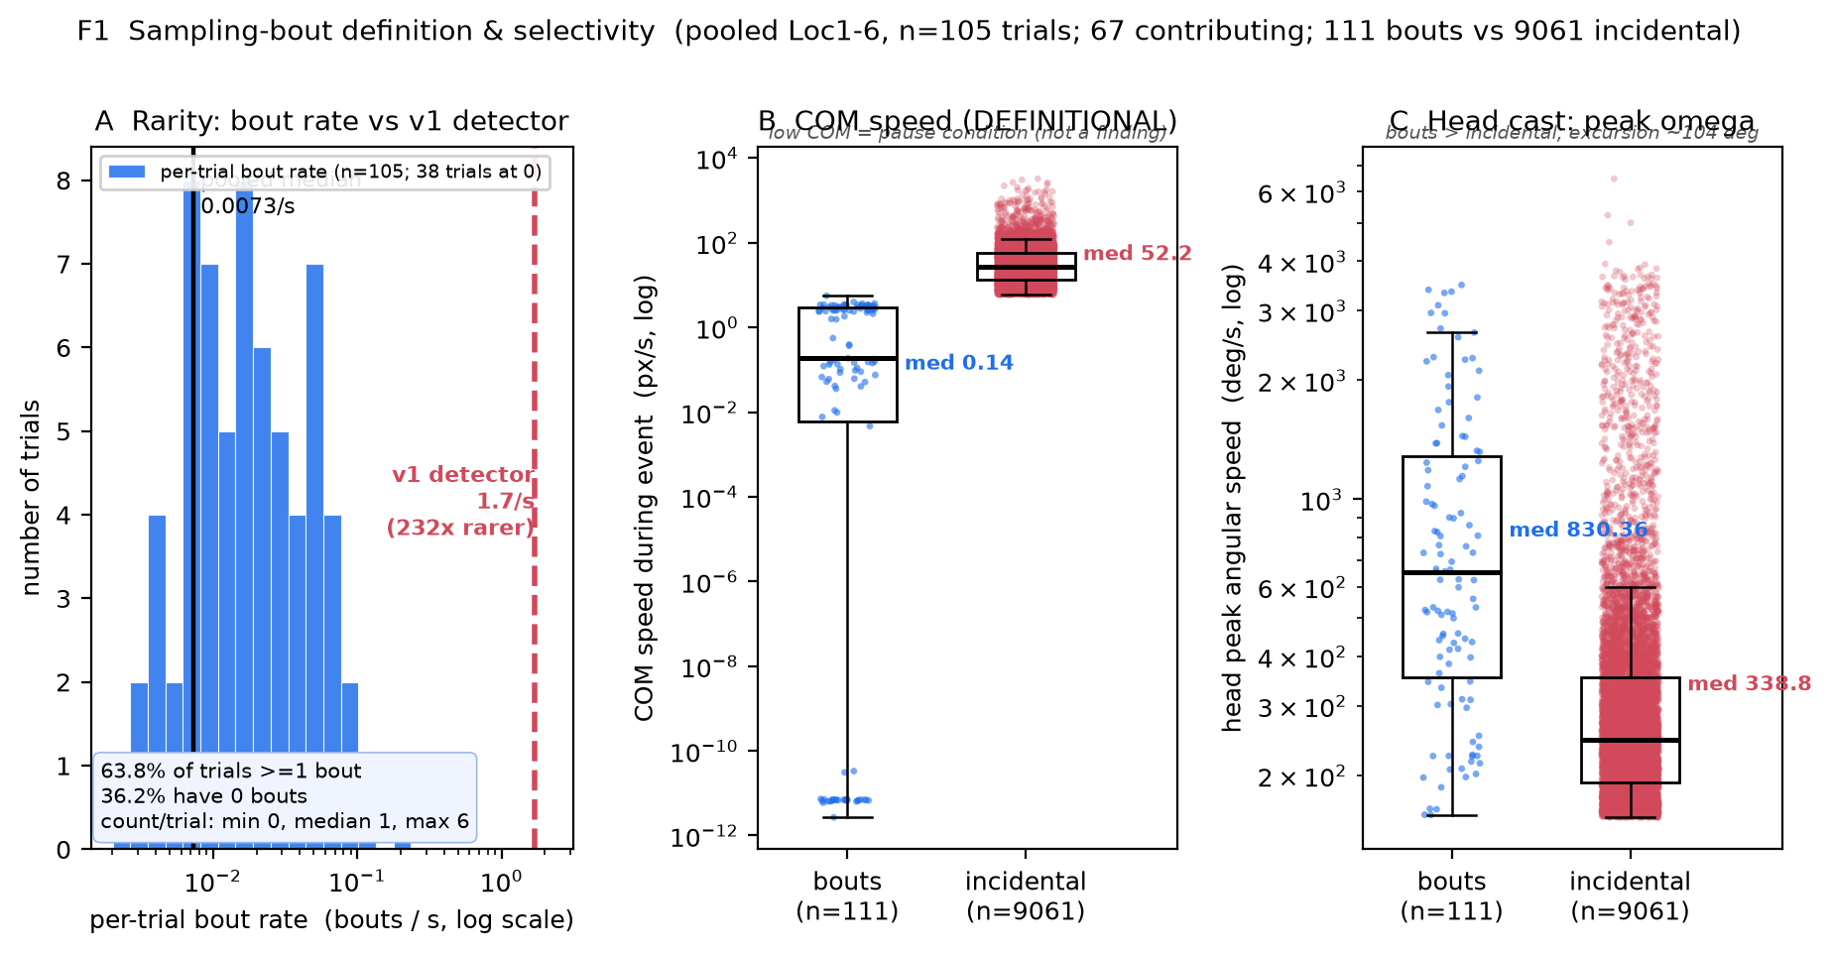
Figure F1. Sampling-bout definition and selectivity (pooled Loc1-6, n = 105 trials; 67 contributing; 111 bouts vs 9061 incidental events). (A) Per-trial bout-rate distribution (log x); black line = pooled median 0.0073/s, red dashed line = v1 detector rate 1.7/s (232x rarer). 63.8% of trials have >=1 bout, 36.2% have zero. (B) COM speed during event: bouts (median 0.14 px/s) << incidental (median 52.2 px/s) -- this low-COM separation is DEFINITIONAL (the pause condition), not a finding. (C) Head peak angular speed: bouts (median 830.4 deg/s) > incidental (median 338.8 deg/s); median bout angular excursion 104 deg.

Rarity: the redesign selects rare, deliberate events
The redesigned detector produces a rare event. The pooled median bout rate is 0.0073/s (trial-bootstrap mean 0.0180/s, 95% CI [0.0127, 0.0236]/s) -- 232x rarer than the v1 detector's 1.7/s. Per trial, the bout count distribution is min 0, median 1, max 6. 63.8% of trials contain at least one bout, while 36.2% contain none -- i.e., most head motion is NOT sampling.
D6 rarity gate: PASSED. The achieved median rate (0.0073/s) is far below the tighten trigger (0.5/s), so parameters were NOT tightened (d6_tightened = False). Loosening was deliberately avoided, as it would re-admit routine motion. The rate sits below the aspirational 0.05-0.3/s target and is accepted as maximally specific; the resulting modest sample (67 contributing trials, 111 bouts) is carried forward as a documented power caveat.

Selectivity: bouts vs incidental motion
Low COM speed is DEFINITIONAL, not a finding. Bouts require a locomotor pause; low v_com during bouts is DEFINITIONAL, not a result. By construction, bouts occur during a locomotor pause, so their COM speed is very low (median 0.14 px/s) versus incidental high-omega events while moving (median 52.2 px/s; trial-level Wilcoxon incidental > bout, W = 2278, p = 5.6e-13, n = 67 trials). This separation restates the pause condition and must not be read as a result -- it was exactly v1's circular error, and is reported here only to confirm the detector behaves as defined.
Head casts are larger during bouts (a genuine selectivity property). Bout events show substantially larger head casts than incidental motion: peak angular speed median 830.4 deg/s for bouts versus 338.8 deg/s for incidental (trial-level Wilcoxon bout >= incidental, W = 2174, p = 5.1e-11, n = 67 trials), with a median angular excursion of 104 deg per bout. Bouts are therefore not merely 'slow moments' -- they are pauses accompanied by pronounced, deliberate head sweeps.

Sanity note
A representative high-activity example is trial index 47 (11-23-2019-4-04 PM-Mohammad-207_Trial3_Loc4.avi.dat), with 6 bouts at a per-trial rate of 0.0656/s -- consistent with the pooled distribution and with visible pause-plus-head-cast episodes.

Caveats
- Modest N: only 67 of 105 pooled trials contribute at least one bout (111 bouts total). Trial-level power for the downstream odor hypotheses (H1-H3) is limited; effect magnitudes are led over p-values.
- Single cohort, pixel units: results derive from one infrared cohort with spatial quantities in camera pixels (px, px/s); no cross-cohort or metric-unit generalization is claimed.
- Low-COM is definitional: the bout-vs-incidental COM-speed gap (median 0.14 vs 52.2 px/s) is imposed by the pause condition and carries no inferential weight.

Reproducibility
Exact command (pinned interpreter; headless matplotlib):
"C:/Projects/Repos/Agentic Research/Research Setup/vras/Scripts/python.exe" code/make_F1.py # figure
"C:/Projects/Repos/Agentic Research/Research Setup/vras/Scripts/python.exe" code/make_report_A.py # this report
Result files (read-only inputs; no science recomputed by figure/report builders):
- data/stats.json -- all injected numbers (deliverable_A: rarity, selectivity; meta parameters)
- data/bouts.h5 -- figure_curves/F1_* arrays for the plotted distributions
- reports/figures/F1_bout_definition.{png,pdf,txt} -- Figure F1 and its numeric sidecar
Seed 1234; library reactions2_common/1.0; unit of analysis = trial; pooled Loc1-6 (n = 105).

